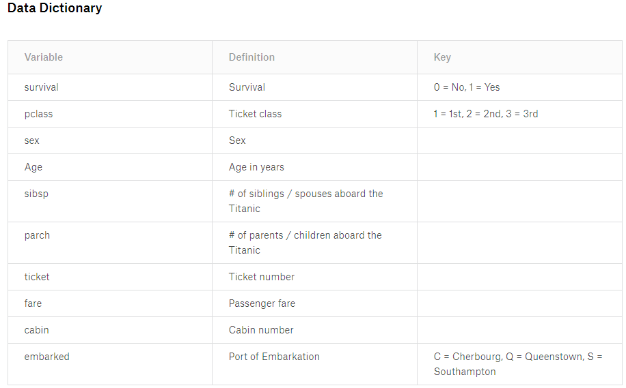

**Variable Notes**

pclass: A proxy for socio-economic status (SES)  
1st = Upper  
2nd = Middle  
3rd = Lower  
  
age: Age is fractional if less than 1. If the age is estimated, is it in the form of xx.5  
  
sibsp: The dataset defines family relations in this way...  
Sibling = brother, sister, stepbrother, stepsister  
Spouse = husband, wife (mistresses and fiancés were ignored)  
  
parch: The dataset defines family relations in this way...  
Parent = mother, father  
Child = daughter, son, stepdaughter, stepson  
Some children travelled only with a nanny, therefore parch=0 for them.